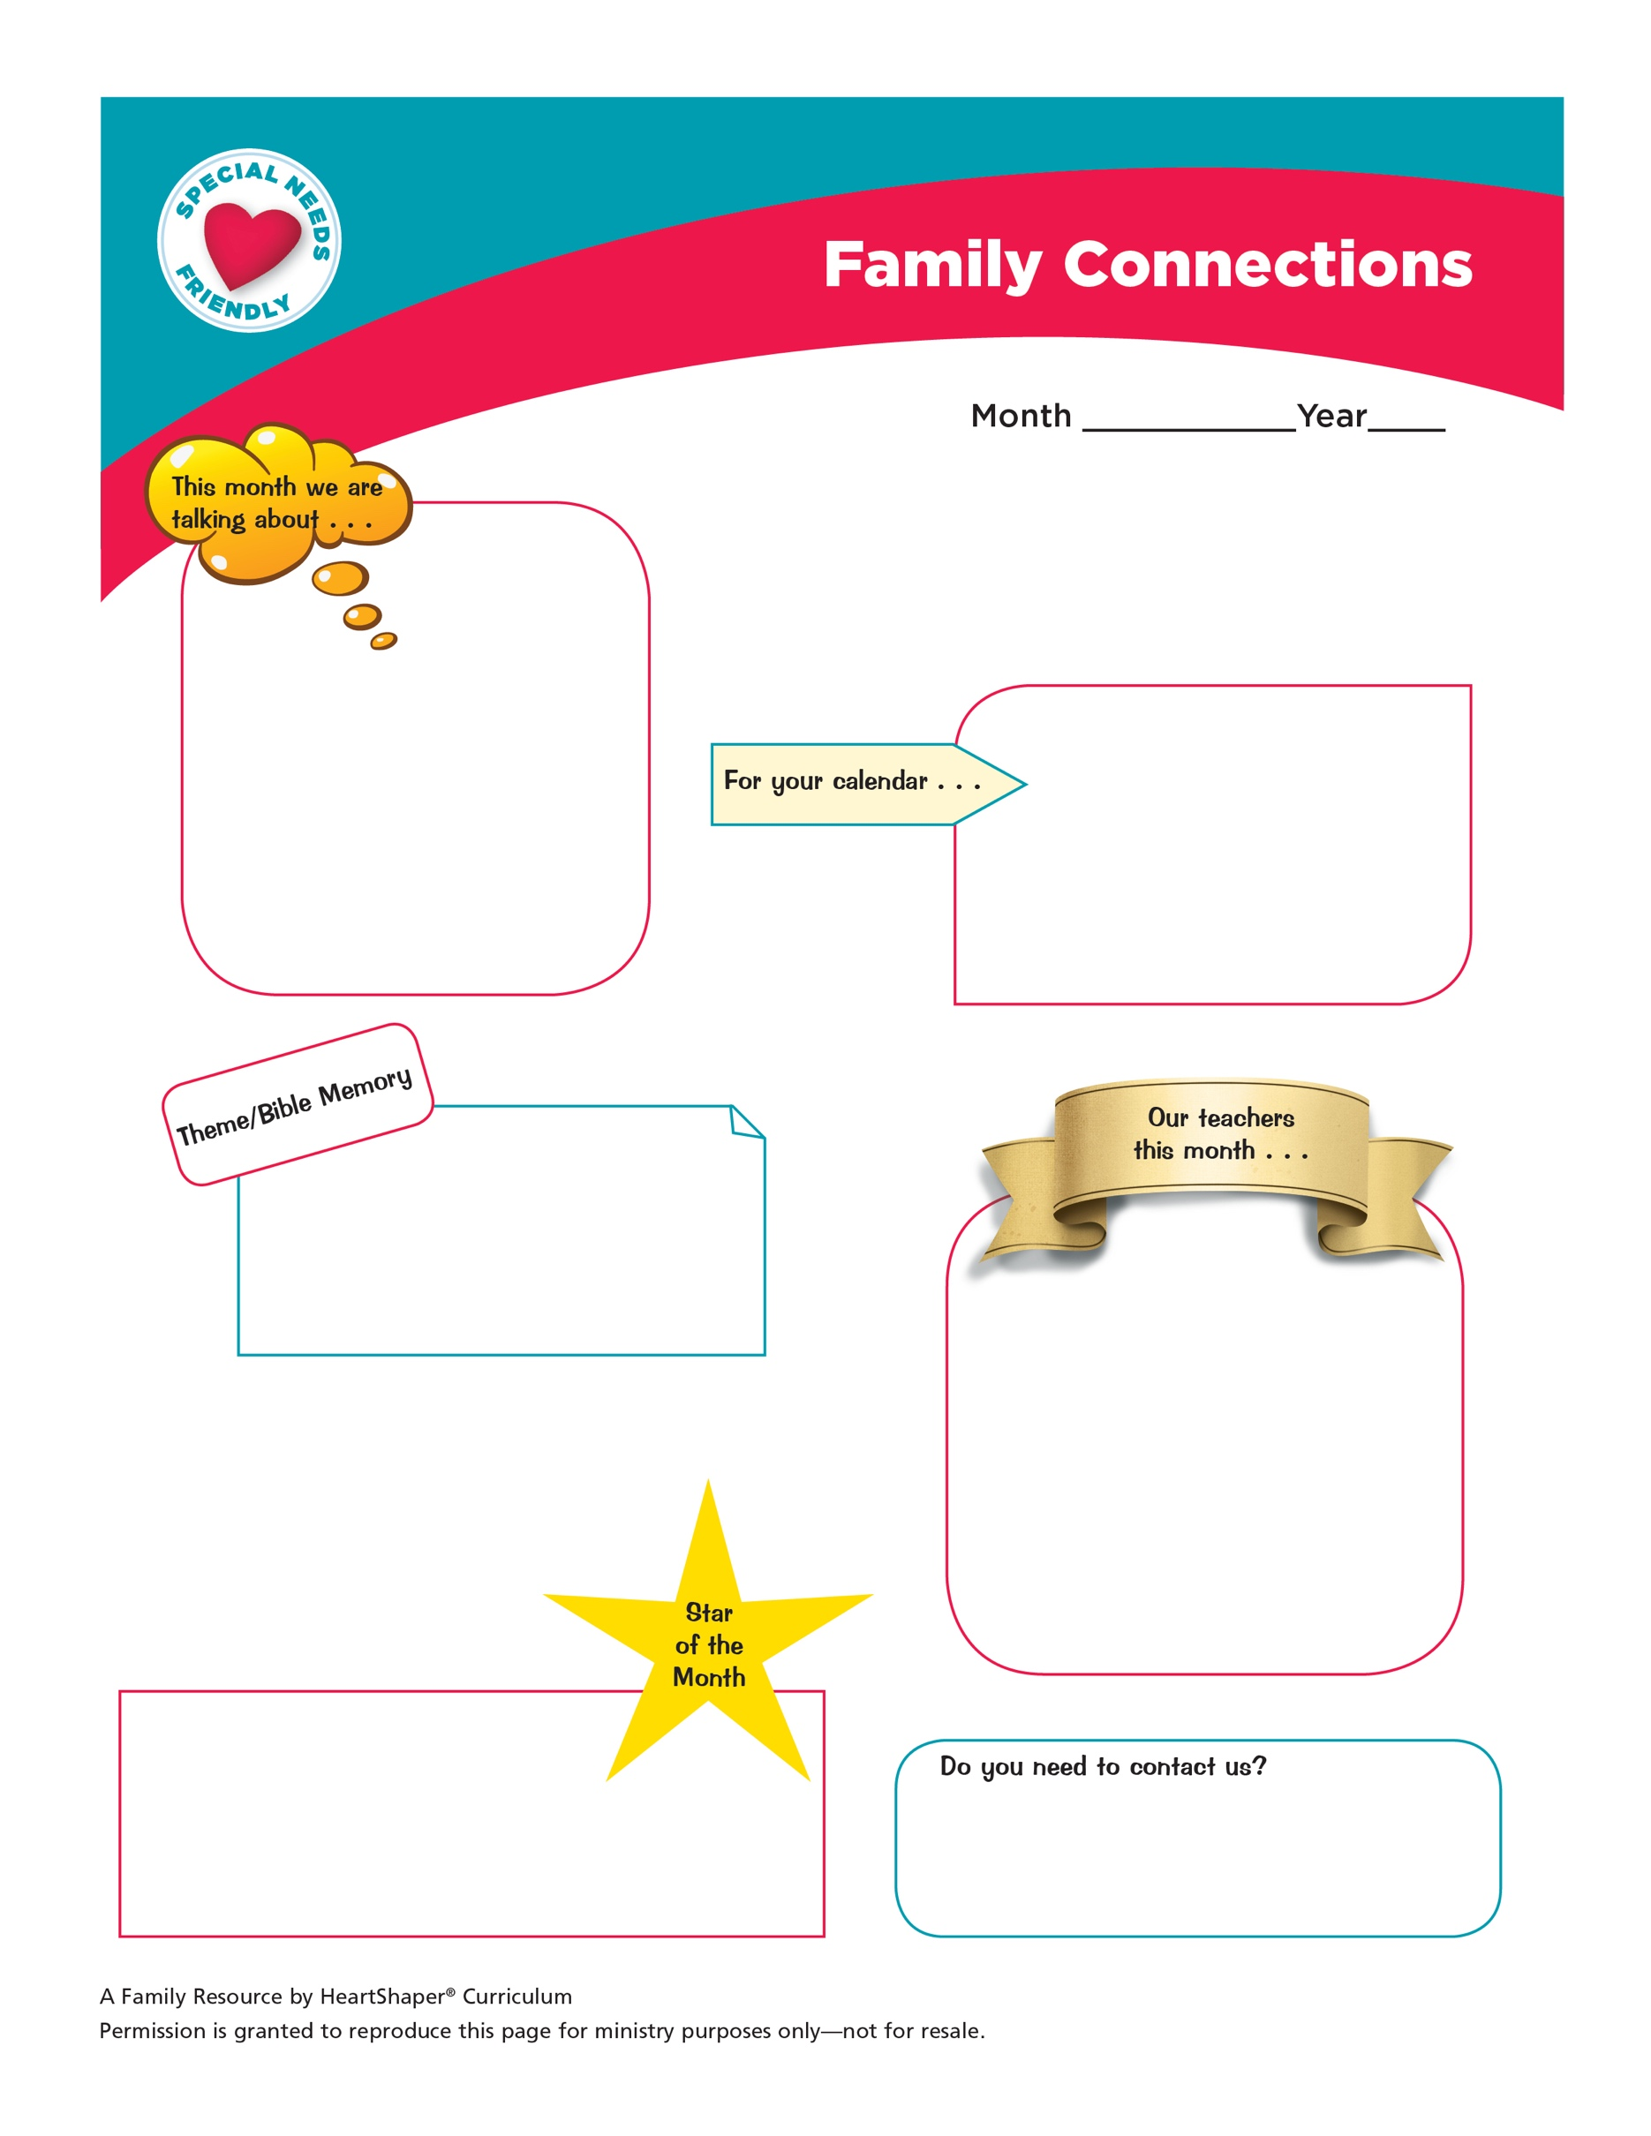

<Type here your church or ministry name, along with contact information>

<Copy and paste student photo here>

**Welcome to Family Connections—**a monthly newsletter that helps you know what Is happening in your child’s classroom. Please let us know if we can help you in any way as we partner with you to nurture kids in Jesus.

<Type information here>

<Type information here>

<Type information here>

<Type information here >

<Type student bio here>

<Year>

<Month>